Running on Empty
Canada and the Indochinese Refugees, 1975–1980
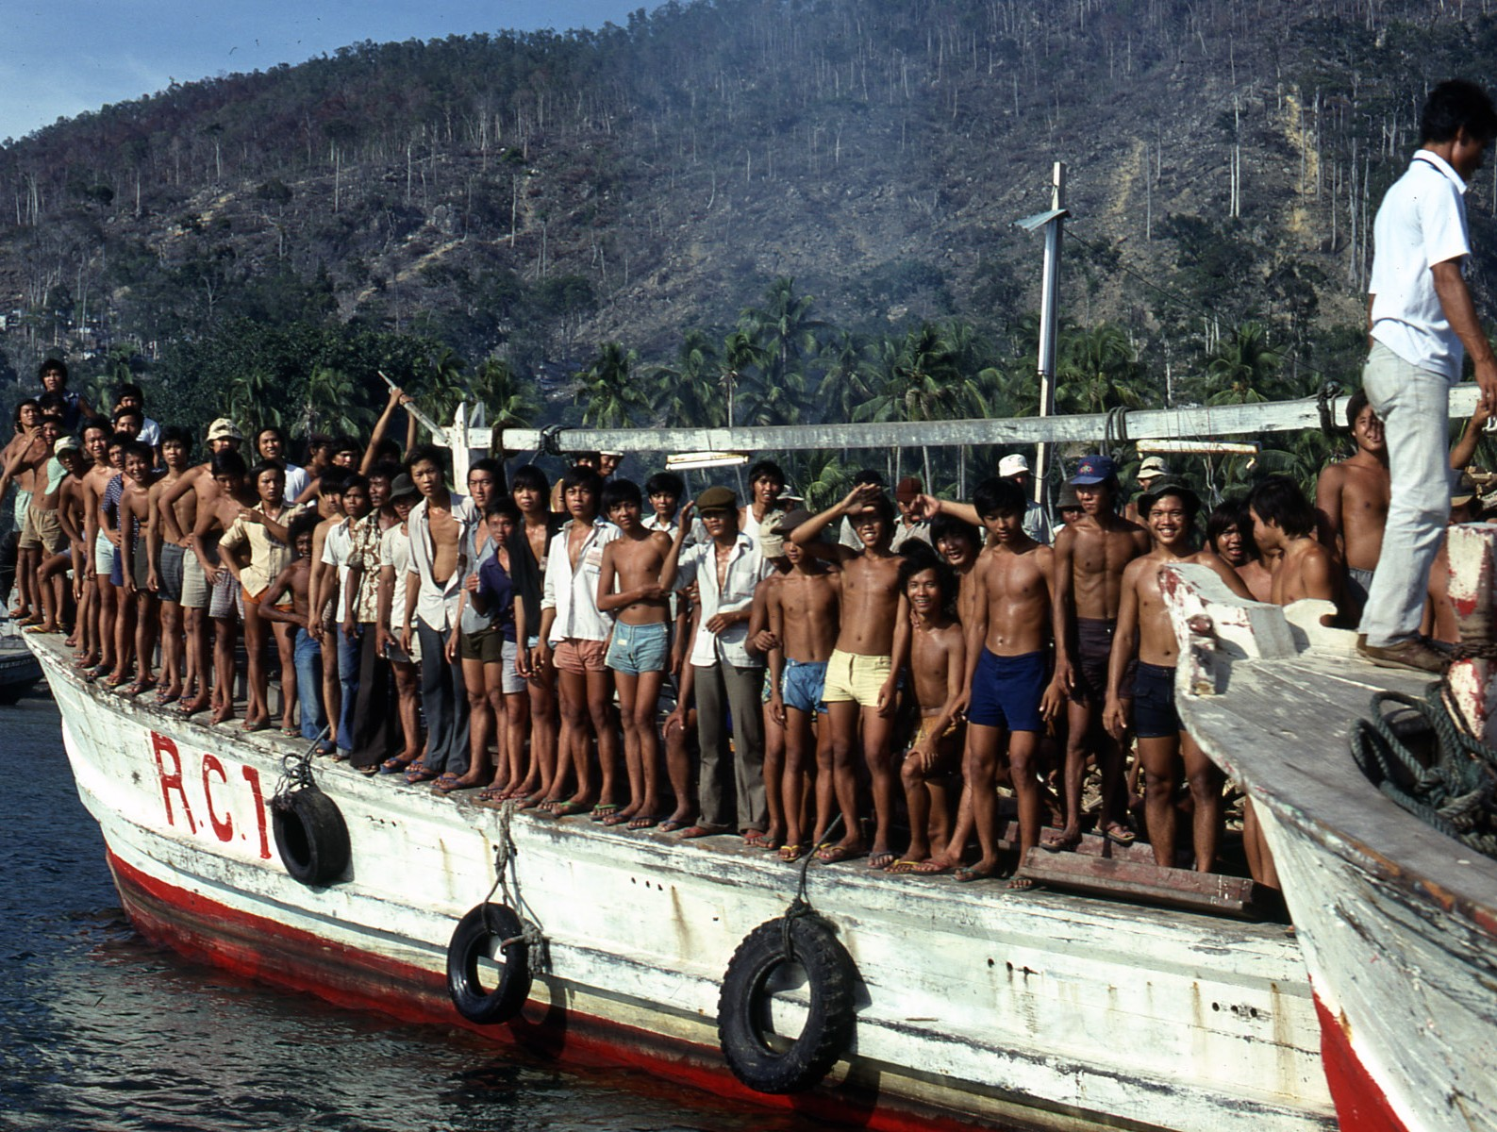

Michael J. Molloy, Peter Duschinsky, Kurt F. Jensen, and Robert J. Shalka
McGill-Queen’s University Press, April 2017
Vietnam, Cambodia and Laos fell to communist forces in April 1975, creating a flood of refugees. Forty-two years later, April 2017, McGill-Queen’s University Press will release a major new work, Running on Empty: Canada and the Indochinese Refugee Movement 1975-1980, written under the auspices of the Canadian Immigration Historical Society. The book focuses on the work of Canadian public servants in Southeast Asia and Canada to meet an unprecedented commitment to resettle 70,000 of the refugees before the end of 1980.
Responding to intensive media reports of dramatic outflows of Vietnamese “boat people” and massive population displacements from Cambodia and Laos, Canada’s federal government committed to the admission of first 5000, then 12,000, then 50,000 and ultimately 60,000 refugees. This was on top of almost 10,000 admitted in the aftermath of the fall of Saigon in 1975. In a remarkable outpouring of humanitarian concern, thousands of Canadians from every field of endeavor took advantage of a new and unique private sponsorship program to sponsor the admission and resettlement of 40,000 of the refugees, people whose culture and languages were profoundly different from those of the Canadian mainstream.
This massive humanitarian undertaking relied on the efforts of a rather small number of government employees, immigration officers, doctors, RCMP officers and members of the Canadian forces. As the title indicates, by the end of 1980 — after intense efforts selecting refugees from lonely Southeast Asian camps on tiny islands and in the depths of steaming jungles, welcoming them at reception centres in Montreal and Edmonton, matching them with sponsors and communities and sending them to small towns and big cities across Canada — public servants were exhausted, they were “running on empty.”
The goal of this book is to record this great endeavour in the words of those who made it happen.
This is not a dry academic book. Its stories are often heartwarming, sometimes tragic and occasionally humorous. In gathering accounts from many sources, Running on Empty describes the immediacy and challenges of resettling refugees. Contemporary photographs provide the visual backdrop to the dramatic events in Southeast Asia. Some typical narratives contained in the book:
- The story of visa officers, military pilots, NGO personnel, provincial bureaucrats and the wives of diplomats — rescuing Vietnamese and Cambodian babies from Saigon under siege.
- Interviews with two visa officers recalling their adventures on the dangerous back roads of Malaysia and Thailand.
- High sea rescues by freighter captains, the odysseys of these boat people across oceanic distances and how Canadian officers travelled from distant embassies to accept them.
- Canada’s leading role in accepting refugees off the Hai Hong, a freighter with 2,500 refugees on board, stranded near the coast of Malaysia.
- The recollections of three visa officers helicoptered to a tiny uninhabited island in the South China Sea to interview a thousand stranded boat people.
- The arrival of the first refugees at CFB Longue Pointe in Montreal and the efforts of Canada’s military to help them during their first days in Canada.
- The effective cooperation between federal and Quebec officers in the field.
- A refugee liaison officer in Kitchener handling a difficult question posed by a newly arrived Hmong refugee from Laos: “what does it mean to be a good woman” in Canada?
A country founded by immigrants and their descendants, first French and then British, Canada resolutely resisted admitting people from non-European sources for the first half of its existence. In 1947, Prime Minister Mackenzie King insisted that “the people of Canada do not wish, as a result of mass immigration, to make fundamental changes in the character of our population,” our British-French cultural duality. But by the 1960s, Canada’s social framework was undergoing major change: it was becoming multi- rather than bicultural. British imperial values yielded to an awareness of equality, fairness and human rights and an emphasis on pluralism and ethnic diversity, opening the door to immigrants from all parts of the world.
From the 1960s through the late 1970s Canada’s refugee policy framework was brought into line with an evolving multicultural value system. The most dramatic expression of this change in values was the response of the government and so many Canadians to the unfolding refugee tragedy in Southeast Asia.
In addition to first-hand narratives by public servants, Running on Empty, through an analysis of archival records of debates within the public service and their influence on government deliberations and political decisions, describes the evolution of Canada’s immigration and refugee legislation and its on-the-ground implementation. The new legislation, as well as the leadership provided by successive Liberal and Progressive Conservative governments, created a domestic and international policy framework that embraced ethnic diversity and through which Canada’s public servants selected and resettled refugees from Southeast Asia between 1975 and 1980. One of the most important elements of the new immigration law of 1976 was the private refugee sponsorship system allowing ordinary citizens to assume responsibility for resettling these refugees. That these non-European refugees were enthusiastically embraced by Canadians contributed decisively to the success of this movement. That generosity triggered the United Nations High Commissioner for Refugees to award the Nansen Medal, the refugee equivalent of the Nobel Prize, to the “People of Canada” in 1986.
As Canadians rally now to the cause of the Syrian refugees, the Indochinese precedent has been repeatedly cited. We hope that this example from the past, described in Running on Empty, will inspire sustained efforts on behalf of victims of persecution and displacement in a troubled world.

